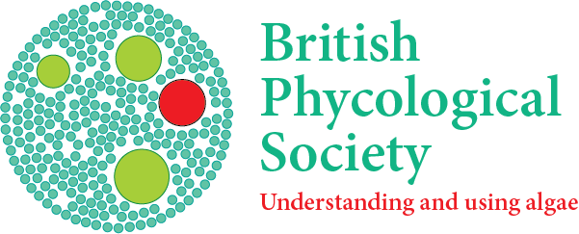
Project Award Application
DEADLINE: 23:00 GMT 1st May,

Form for Electronic Submission to https://brphycsoc.org/award-submission-portal/
Applications are to be left in Word format and not converted to PDF.

Project Awards are to support hypothesis-driven projects that promote and further phycology, its applications and dissemination. They are not intended to fund PhD research.
Before you complete this form, please read the BPS Funding Guidelines document on the Society’s website. Use Calibri font size 12 throughout and do not exceed 5 pages.

Full name of Project Lead:

Department and Institution or organisation:
Street Address
Postal/ZIP code
Country
Phone Number:
E-mail:
Date(s) of joining BPS:
Co-Investigator (if any) and address.
Brief details of any previous support from BPS Awards & Training with dates
Application deadline:
How many hours per week would the Project Lead work on the project?
Title of Project:
Proposed Start and End Dates:
Note: The usual maximum duration for a Project Award is 24 months. In exceptional and well justified circumstances, a longer project can be proposed, but this must be discussed with the Chair of the BPS Awards and Training Committee awards@brphycsoc.org ahead of submission.
Description of Project:

Objectives of Project:
Beneficiaries:

Plans for Dissemination of Project Outputs:

Track Record of Applicant(s):

Justification of Resources Requested:

Relevant Publications (max. 6):

Breakdown of total costs in local currency and Pounds Sterling and the sum requested from BPS. Note: please do not include staff time. Max. award £8,000.
Item | Local Currency | £
1. Consumables

2. Travel:

3. Other

Total Cost
Sum Requested from BPS

The completed application must not exceed 5 A4 pages. Applications exceeding the page limit will not be considered.

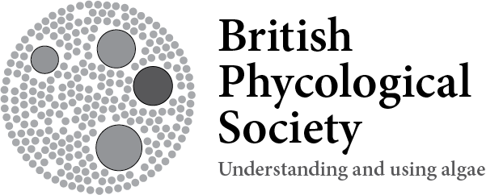
Equal Opportunities Monitoring Form
In Confidence
Policy The British Phycological Society is committed to promoting diversity and equal opportunities, and aims to have an inclusive environment for all members, by identifying and removing barriers in our practices. Completing this monitoring form will help us achieve this, and also help the BPS meet our obligations under the Equality Act 2010. While it is voluntary to disclose this information, doing so will enable us to better understand the composition of our membership and examine our practices fully. Our intention is to reflect not only the letter but also the spirit of diversity and equal opportunities legislation and we oppose all forms of unlawful and unfair discrimination.
Monitoring You are asked to provide the information below because BPS will monitor equality information for people who apply for grants and other support from the Society, and for people elected to Council or appointed to roles. The information will be treated as strictly confidential and used to ensure that policies and practices are fair and do not discriminate.
Please complete all sections of this form
Name of member:

Ethnicity: What is your ethnic origin?

Asian / Asian British Mixed / multiple ethnic groups
☐ Indian ☐ White and Black Caribbean
☐ Pakistani ☐ White and Black African
☐ Bangladeshi ☐ White and Asian
☐ Chinese ☐ Any other Mixed/multiple ethnic background (write in):
☐ Any other Asian Background (write in):
Black / African / Caribbean / Black British White
☐ African ☐ British/English/Welsh/Scottish/Northern Irish
☐ Caribbean ☐ Irish
☐ Any other Black/African/Caribbean background (write in): ☐ Gypsy or Irish Traveller
☐ Any other White background (write in):
Other Ethnic Background
☐ Arab ☐ Prefer not to say
☐ Any other ethnic group (write in):

Gender
I am: Is your gender identity the same
gender you were assigned at birth?
☐ Male ☐ Yes
☐ Female ☐ No
☐ Prefer not to say ☐ Prefer not to say

Age: please indicate your age group (years)
☐ less than 18 years ☐ 45 - 54
☐ 18 - 24 ☐ 55 - 64
☐ 25 - 34 ☐ over 65
☐ 35 - 44 ☐ Prefer not to say

Religion or belief
What is your religion?
☐ Christian (including Church of England, Catholic, Protestant and all other Christian denominations)
☐ Buddhist ☐ No religion
☐ Hindu ☐ Prefer not to say
☐ Jewish ☐ Any other religion or belief (write in)
☐ Muslim ☐ Prefer not to say
☐ Spiritual

Sexual orientation
What is your sexual orientation?

☐ Asexual ☐ Heterosexual / straight
☐ Bi/bisexual ☐ Queer
☐ Gay man ☐ Other
☐ Gay woman / lesbian ☐ Prefer not to say

Disability
Do you have an impairment, health condition or learning difference?

☐ Yes* ☐ Unsure
☐ No ☐ Prefer not to say

Please note the Equality Act considers a person disabled if they have a physical or mental impairment or disability that has lasted, or is likely to last, at least 12 months which has a substantial and long-term adverse effect on their ability to carry out normal day-to-day activities.

*If you wish to discuss any reasonable adjustment(s) you may require, please respond to awards@brphycsoc.org

This form has been based on the latest guidance and recommendations provided by the Equality Challenge Unit
Thank you for completing this form

